## Installing SharePoint Server 2010

**Lab Time**: 45 minutes

**Lab Folder**: C:\Student\Labs\02.Install

**Lab Overview**: In the following lab, you will learn how to install and configure SharePoint 2010.

Lab Setup Requirements

* Before you begin this lab, you must have the WingtipServer virtual machine running.

### Exercise 1: Create Dedicated Service Accounts in Active Directory

In this first exercise, you will create the new user accounts in the wingtip.com domain to act as service accounts for the SharePoint farm you will be working without throughout this track of lab exercises. You will create these accounts by running a Windows PowerShell script.

1. Log onto the **WingtipServer** VM.
2. In the Windows Explorer, navigate to [[Lab Files]]\Starter Files\Scripts. Inside the Scripts directory you should be able to locate several files including two Windows PowerShell scripts named CreateWingtipServiceAccounts.ps1 and CreateWingtipUsers.ps1.

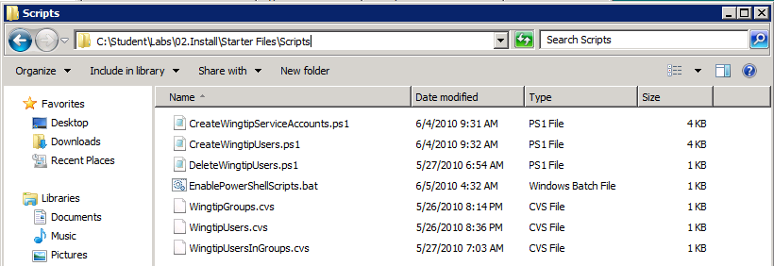

1. Before you can run a Windows PowerShell script on the VM, you must change a machine-wide Windows PowerShell setting known as the **ExecutionPolicy**. You will learn more about this in the upcoming lecture on Windows PowerShell. For now, you should right click on the Windows batch file named EnablePowerShellScripts.bat and click **Run as administrator**.

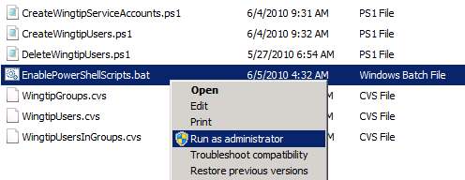

1. Now you will run the Windows PowerShell script named CreateWingtipServiceAccounts.ps1. When you run this script, itwill create the following three service accounts in the **wingtip.com** domain.
   1. **sp_farm**: this account is only used for Central Admin Web App and creating the configuration database
   2. **sp_serviceapp**: this account is used for all service applications
   3. **sp_webapp**: this account is used for all web applications
2. Right click on CreateWingtipServiceAccounts.ps1 and click the menu command titled **Run with PowerShell**.

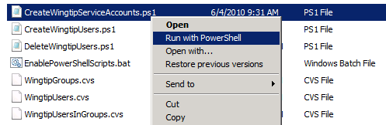

1. Running the script should produce the following output in the console window.

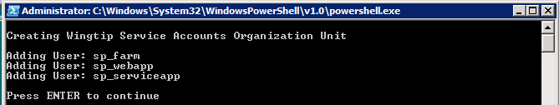

1. Upon the script’s completion, the three service accounts should have been created in Active Directory. You can verify this by making sure you can see the accounts inside Active Directory.
2. Run the administrative console for **Active Directory Users and Computers** by running the following command from the Windows Start menu: **Start » Administrative Tools » Active Directory Users and Computers**.
   1. Expand the **wintip.com** node if is not expanded already.
   2. Select the **Wingtip Service Accounts** group. Here you should see the three service accounts.

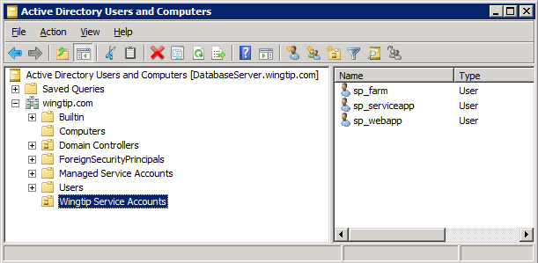

1. In the Scripts directory, you can find a second Windows PowerShell script named CreateWingtipUsers.ps1. Executing this script will also create a number of “normal” users. Run CreateWingtipUsers.ps1 by right clicking it and clicking the menu command titled **Run with PowerShell**.

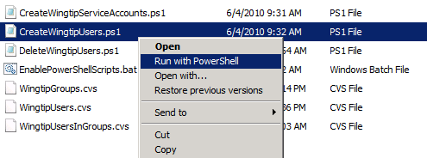

1. Running the script should produce the following output in the console window.

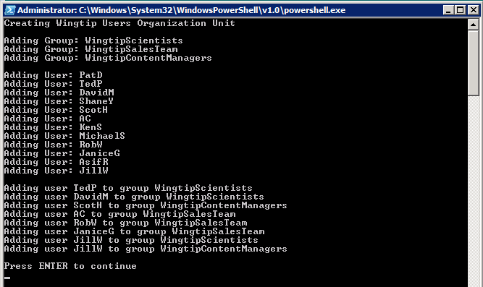

1. Upon the script’s completion, the Wingtip user accounts should have been created successfully. You can verify this by making sure you can see the accounts inside Active Directory.
2. Return to the administrative console for **Active Directory Users and Computers**.
   1. Right-click on the top node for **wintip.com** node and run the **Refresh** command.
   2. Select the **Wingtip Users** group. Here you should see new Wingtip accounts.

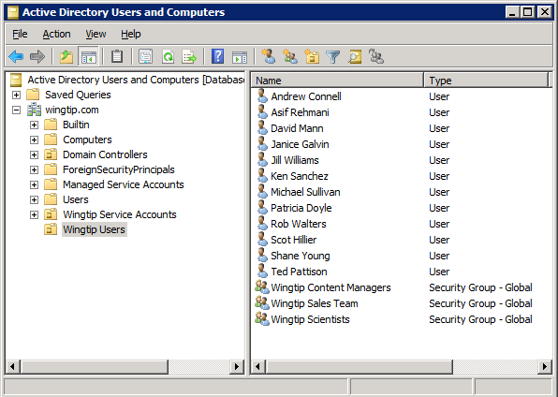

### Exercise 2: Install SharePoint Server 2010

In this exercise you will install SharePoint Server 2010 and create a new farm for Wingtip Toys.

1. Log onto the **WingtipServer** VM using the **WINGTIP\Administrator** account.
2. Verify the SharePoint Server 2010 installation files are already on the VM.
3. Open **Windows Explorer**.
   1. Verify there is an existing directory at the path of C:\Install.
   2. Inside the C:\Install directory, verify that there is a child directory named SharePointServer2010 which holds the installation files for SharePoint Server 2010.
   3. Inside the C:\Install directory, verify that there is a file named Windows6.1-KB982307-x64.msu. You will use this installation file in the next step to install a component named **WCF Data Services** which must be installed by hand in order to take advantage of the new support for REST-based access to list items in SharePoint 2010.
4. Run the **SharePoint 2010 Prerequisite Installer**.
5. Ensure that the **WingtipServer** VM is able to access the Internet before moving on to the next steps.
   1. Navigate to C:\Install\SharePointServer2010 and double click on PrerequisiteInstaller.exe to run this program.
   2. Click **Next** at the welcome screen and accept the licensing agreement to install the SharePoint Server prerequisites.
   3. When running PrerequisiteInstaller.exewill see display a dialog informing you what has been installed and telling you that a system restart is required. Click **Finish** to reboot the **WingtipServer** VM.

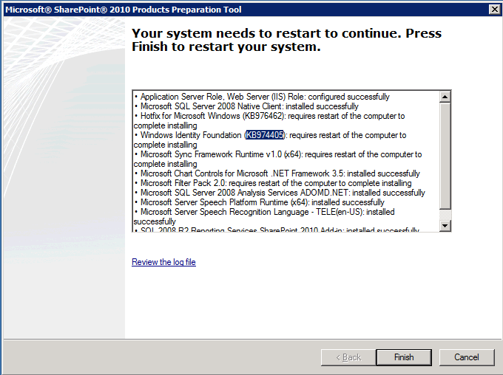

* 1. After the VM has restarted (if neccessary), log as **WINGTIP\Administrator**. The PrerequisiteInstaller.exeprogramwill continue.It should finish and display an **Installation Complete** message. Click **Finish** to complete the PrerequisiteInstaller.exe program.

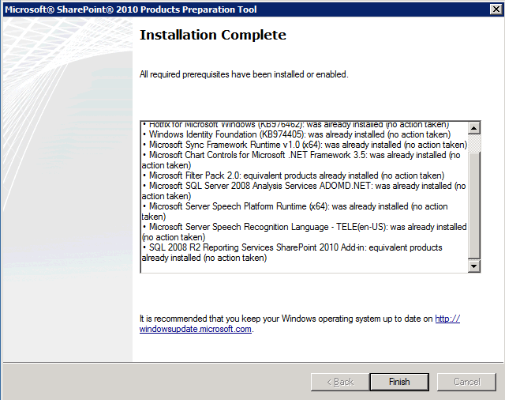

1. Install **WCF Data Services**.
2. Navigate to C:\Install and double-click on Windows6.1-KB982307-x64.msu to begin the installation of WCF Data Services.
   1. Click **Yes** when prompted whether you want to install **Hotfix for Windows** (**KB982307**)

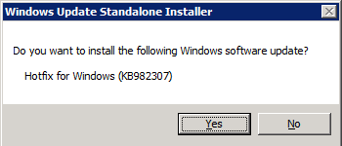

* 1. When the **WCF Data Services** update completes, click **OK** and then reboot the computer if prompted to reboot.

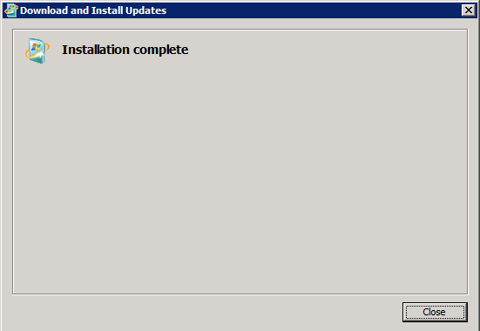

* 1. After the **WingtipServer** VM has restarted, log as **WINGTIP\Administrator**.

1. Install **SharePoint Server 2010 Enterprise**.
2. Inside the top-level directory of the SharePoint Server install files, locate and run setup.exe.
   1. When you first run setup.exe, you will be prompted to enter a product key for SharePoint Server 2010.

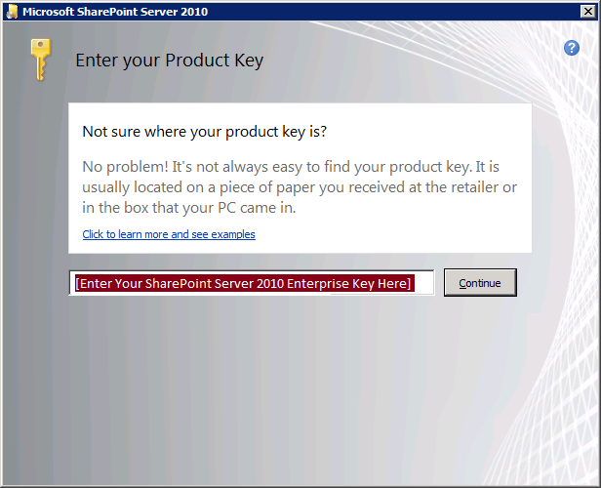

* 1. Enter the following trial key for SharePoint Server 2010 Enterprise Client Access License features and then click **OK** to continue.

GGDG8-JCMXH-8KG8C-RJYYX-3Y33H

* 1. When installation is finished, you are prompted to **Run the SharePoint Products and Technologies Configuration Wizard now**. Click **Close** to begin this wizard.

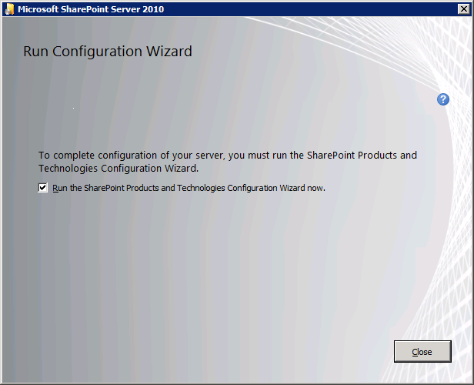

1. Create the **Configuration Database** and **Central Administration Web application** using the SharePoint Products and Technologies Configuration Wizard.
2. On the **Welcome to SharePoint Products** page, click **Next** to continue.

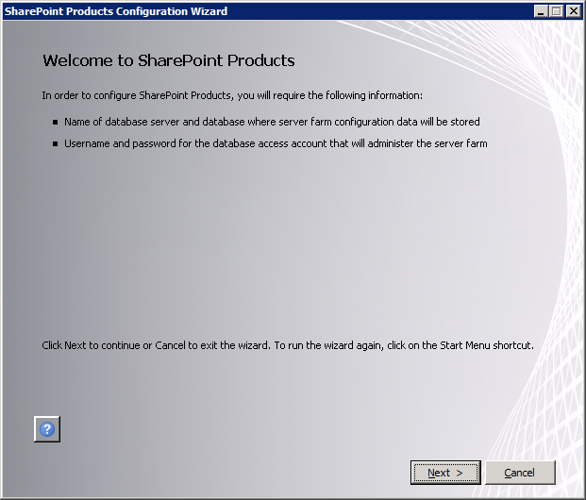

* 1. A dialog will ask you whether it is OK to stop IIS and a few other services. Click **Yes** on this dialog to continue with the configuration process.

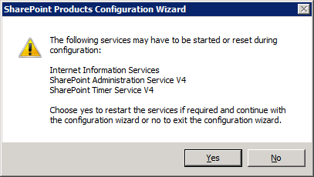

* 1. On the **Connect to a server farm** page, select **Create a new server farm** and click **Next** to continue.

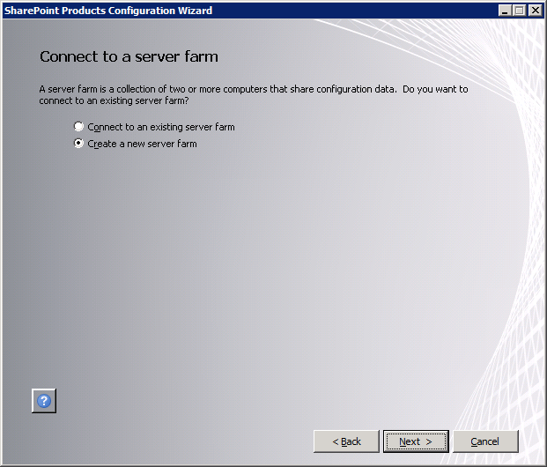

* 1. The next page is the **Specify Configuration Database Settings** page. Fill in these settings with these values:

**Database server:** WingtipServer

**Database name:** Wingtip_ConfigDB

**Username:** WINGTIP\sp_farm

**Password:** Password1

* 1. One you filled in the configuration database settings, click **Next** to continue.

NOTE: If you fail to connect after clicking **Next** you might have a connectivity issue with SQL Server 2008 R2. SQL Server 2008 R2 is configured to disallow TCP\IP connections after the initial installation. If you are not able to connect you should use the SQL Server Configuration Manager to enable TCP\IP connection as described in the class setup document.

* 1. The next page is the **Farm Security Settings** page which asks you to add and confirm a passphrase. Add and confirm a passphrase value of **Password1** and click **Next** to continue.

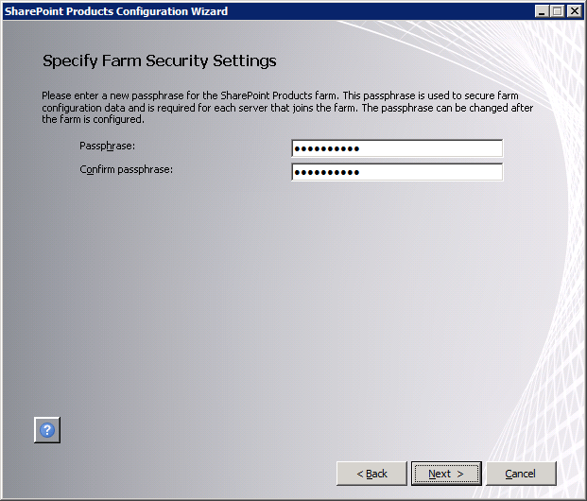

* 1. On the **Configure SharePoint Central Administration Web Application** page, select the option to **Specify port number** and add a port number value of **9999**. Leave the **Configure Security Settings** authentication provide settings at the default value of **NTLM**. Click **Next** to continue.

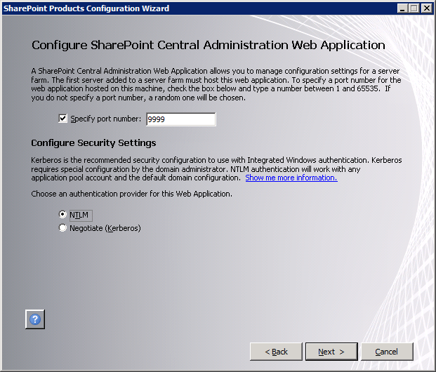

* 1. Review your configuration settings in the **Completing the SharePoint Products Configuration Wizard** page. Click **Next** to begin the configuration.

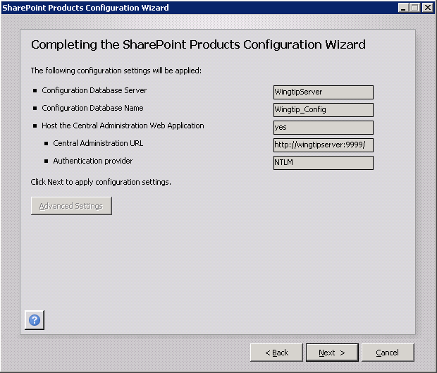

* 1. SharePoint will now begin configuring itself which should take 5-10 minutes depending on the performance of your hardware. When you are done, you will be directed to a page with the title of **Configuration Successful**.

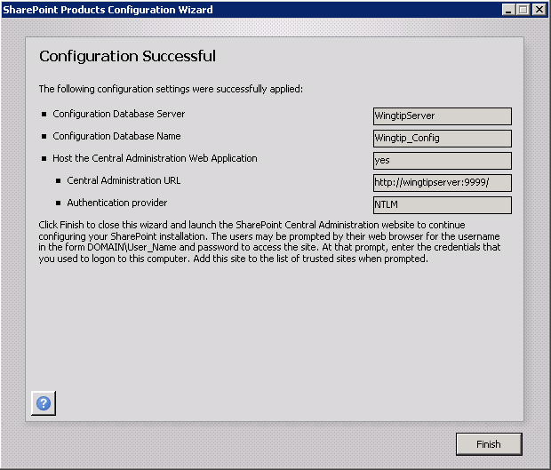

* 1. Click the **Finish** button and you will be directed to a page in Central Administration at the URL of <http://wingtipserver:9999/_admin/adminconfigintro.aspx>.

1. This next page asks you whether you would like to start the **Farm Configuration Wizard**. Configure the farm’s service applications using the **Farm Configuration Wizard**.
2. The first dialog of the **Farm Configuration Wizard** asks you whether you want to participate in the Customer Experience Improvement Program. Select the option **No, I don’t wish to participate** and click **OK** to continue.

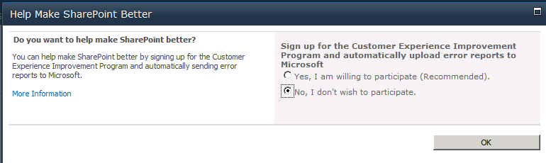

* 1. The next page of the wizard asks **How do you want to configure your SharePoint farm?** Select the option **No. I will configure everything myself.** Click **Cancel** to continue.

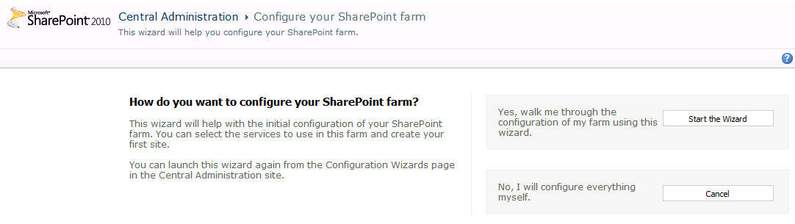

* 1. When you cancel the **Farm Configuration Wizard**, you are redirected to the home page of the **Central Administration** application.

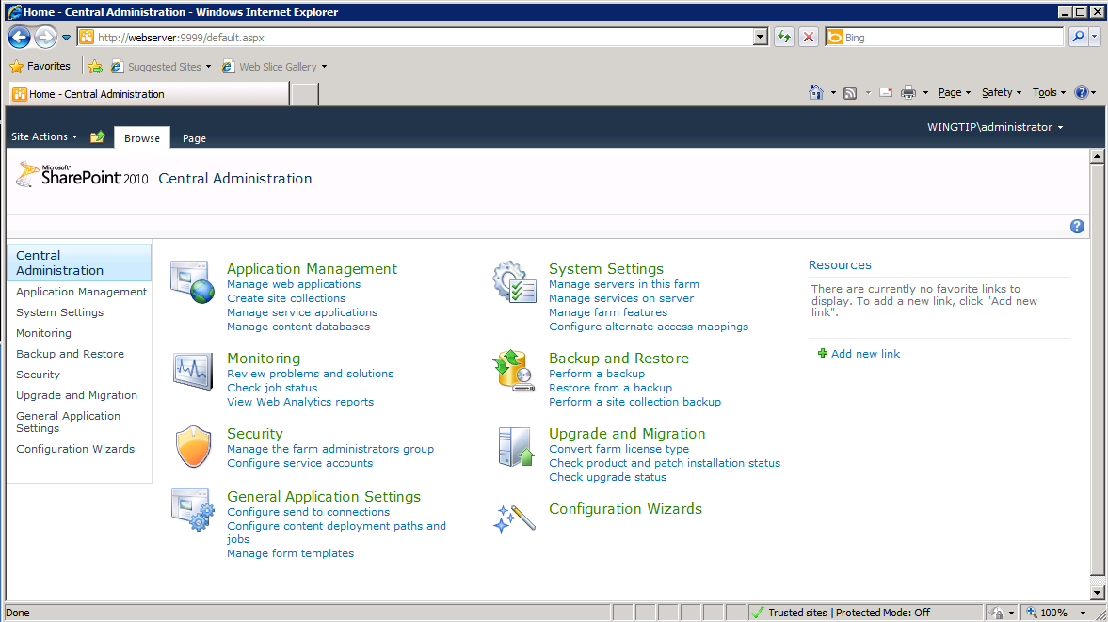

1. You have now completed the basic installation of SharePoint Server 2010 and you have created the configuration database to establish a new farm.

In this exercise you installed the necessary prerequisites, installed and did the initial configuration of SharePoint Server 2010.